
Mercedes College
Examination 2017

Question/Answer Booklet

YEAR 12 ATAR HUMAN BIOLOGY

Name __________________________________________
Teacher’s Name __________________________________________

Time allowed for this paper
Reading time before commencing work: Ten minutes
Working time for paper: 2.5 hours

Materials required/recommended for this paper

To be provided by the supervisor

This Question/Answer Booklet
Multiple-choice Answer Sheet
2 Separate Extended Answer Booklets

To be provided by the candidate
Standard items: pens, pencils, eraser, correction fluid, ruler, and highlighters
Special items: non-programmable calculators satisfying the conditions set by the Curriculum Council for this course

Important note to candidates
No other items may be taken into the examination room. It is your responsibility to ensure that you do not have any unauthorised notes or other items of a non-personal nature in the examination room. If you have any unauthorised material with you, hand it to the supervisor before reading any further.
Structure of this paper

Section | Number of questions available | Number of questions to be answered | Suggested working time  (minutes) | Marks available | Percentage of exam | Student Score
Section One:  Multiple-choice | 30 | 30 | 30 | 30 | 30
Section Two:  Short answer | 10 | 10 | 90 | 100 | 50
Section Three:  Extended answer | 3 | 2 | 60 | 40 | 20
 |  |  |  |  | 100

Instructions to candidates

1. The rules for the conduct of Western Australian external examinations are detailed in the Year 12 Information Handbook 2016. Sitting this examination implies that you agree to abide by these rules.

2. Answer the questions according to the following instructions.

Section One: Answer all questions on the separate Multiple-choice Answer Sheet provided. For each question shade the box to indicate your answer. Use only a blue or black pen to shade the boxes. If you make a mistake, place a cross through that square, do not erase or use correction fluid, and shade your new answer. Marks will not be deducted for incorrect answers. No marks will be given if more than one answer is completed for any question.

Section Two: Write answers in this Question/Answer Booklet.
Section Three: Write each answer in a separate Question/Answer Booklet.

3. You must be careful to confine your responses to the specific questions asked and to follow any instructions that are specific to a particular question.

4. Planning: If you use any spare pages for planning, indicate this clearly at the top of the page.

Continuing an answer: If you need to use the space to continue an answer, indicate in the original answer space where the answer is continued, i.e. give the page number. Fill in the number of the question(s) that you are continuing to answer at the top of the page.

Section One: Multiple-choice 30% (30 Marks)

This section has 30 questions. Answer all questions on the separate Multiple-choice Answer Sheet provided. For each question shade the box to indicate your answer. Use only a blue or black pen to shade the boxes. If you make a mistake, place a cross through that square, do not erase or use correction fluid, and shade your new answer. Marks will not be deducted for incorrect answers. No marks will be given if more than one answer is completed for any question.

Suggested working time for this section is 50 minutes.

The following information is needed to answer the next FOUR questions.

A patient has complained of the following symptoms to their doctor:
- Feeling a lack of energy
- Unexplained weight gain
- Feeling cold, even though the surrounding temperature is around 25°C.

In response, the doctor had the patient’s Thyroid Stimulating Hormone (TSH) levels tested over five consecutive days. The patient’s results, measured in milli-international units per litre (mIU/L), can be seen in the table below.

Day | 1 | 2 | 3 | 4 | 5
TSH concentration (mlU/L) | 2.0 | 2.3 | 2.9 | 2.7 | 2.1

A normal range is between 0.4 to 4.0 mIU/L.

- The range and mean for the patient’s TSH level was

- 2.0 to 2.9 with a mean of 2.5
- 2.1 to 2.9 with a mean of 2.3
- 2.0 to 2.1 with a mean of 2.9
- 2.0 to 2.9 with a mean of 2.2

- TSH is a hormone secreted by

- the hypothalamus and released from the anterior lobe of pituitary gland.
- the posterior lobe of the pituitary gland and its release is controlled by the hypothalamus.
- the anterior lobe of the pituitary gland and its release is controlled by the thyroid gland.
- the anterior lobe of the pituitary gland and its release is controlled by the hypothalamus.

- Based on the information the patient provided, the disease the doctor was most likely checking for was

- type 1 diabetes.
- type 2 diabetes.
- hypothyroidism.
- hyperthyroidism.

- Choose the two correct words to complete the following sentence.
Given the results showed a normal level of TSH present in the blood, the doctor would now need to detect for the presence of __________ to determine if the ________ gland was dysfunctional.

- insulin, pancreas
- thyroxine, parathyroid
- glycogen, pancreas
- thyroxine, thyroid

- Which of the following illustrates a negative feedback mechanism?

- The loss of excess glucose in urine.
- The secretion of oily substances from the sebaceous glands to reduce water
lost from the skin surface.
- The vasoconstriction of the capillaries in the skin to reduce heat loss.
- The mother feeds the baby with breast milk so that the useful nutrients go
back to the human body again.

- Many nerve fibres consist of an axon and its myelin sheath. This myelin sheath is

- responsible for the colour of the grey matter in the brain and spinal cord.
- produced by Schwann cells located along the axon.
- continuous all the way along the cell body.
- responsible for the colour of the grey matter in the peripheral nervous system.

- One hormone molecule causes the manufacture or activation of thousands of enzyme molecules through the process of

- negative feedback.
- enzyme amplification.
- hormone amplification.
- hormone clearance.

- Which of the following statements about ALL hormones is correct? They

- change the functioning of cells by changing the type or quantities of proteins made.
- activate certain genes in the nucleus.
- change the shape or structure of an enzyme.
- change the rate of production of an enzyme.
Refer to the following diagram, showing the processes involved in labour, to answer the next TWO questions.

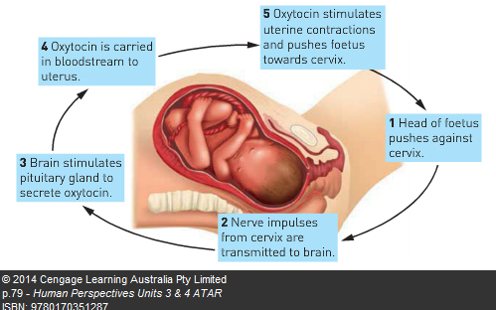

9. In this stimulus-response and feedback process, the effector would be the

- cervix.
- uterus.
- pituitary gland.
- oxytocin.

10. The type of feedback involved in this process would be

- negative feedback, as the response negates the stimulus.
- positive feedback, as the response negates the stimulus.
- negative feedback, as the response intensifies the stimulus.
- positive feedback, as the response intensifies the stimulus.

11. The concentration of CO2 in the blood plasma plays a large role in regulating breathing rate. Which of the following statements is CORRECT?

- High CO₂ levels decrease the acidity of the blood.
- The concentration of CO₂ has to fall to very low levels before it has a major stimulatory effect on breathing.
- The chemoreceptors most sensitive to changes in the concentration of CO₂ in the plasma are those located in the medulla oblongata.
- The chemoreceptors in the carotid and aortic bodies are most sensitive to changes in the concentration of CO₂ in the plasma.

12. Which of the following statements about the autonomic nervous system is INCORRECT?
- It regulates the activities of smooth muscle, cardiac muscle and glands.
- It usually operates without conscious control.
- It is regulated by centres in the cerebral cortex, hypothalamus and the medulla.
- It contains motor and sensory nerve fibres.

Refer to the list below to answer the next question. This information shows some
normal physiological changes in the human body.
    - Dilation of pupils.
    - Increase in heart rate.
    - Decreased secretion of saliva.
    - Increased secretion from sweat glands.
    - Dilation of blood vessels in the skin.
    - Decreased levels of adrenalin in blood.

13. Which of the changes in the above list would result from stimulation by the sympathetic division of the autonomic nervous system?
- A, B, C and E
- A, C, D and F
- A, B, C, and D
- B, C, E, and F

14. Substantial injury to the right cerebral cortex results in loss of:
- voluntary muscular movements of the left side of the body.
- voluntary muscular movements of the right side of the body.
- involuntary muscular movements of the left side of the body.
- involuntary muscular movements of the right side of the body.

Refer to the diagram below to answer the next question.
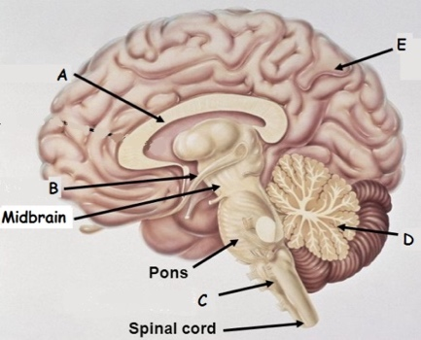

15. Which of the following correctly identifies the structures of the central nervous system?
 | A | B | C | D | E
 | Cerebellum | Hypothalamus | Corpus Callosum | Cerebrum | Pituitary Gland
 | Corpus Callosum | Hypothalamus | Medulla Oblongata | Cerebellum | Cerebrum
 | Hypothalamus | Corpus Callosum | Medulla Oblongata | Cerebellum | Cerebrum
 | Corpus Callosum | Hypothalamus | Cerebellum | Medulla Oblongata | Cerebrum

16. Suffocation victims are usually given a mixture of 95% oxygen and 5% carbon dioxide rather than pure oxygen, because the carbon dioxide:

- Acts on the respiratory centre in the brain to stimulate breathing.
- Decreases the danger of choking by reducing mucous secretion.
- Increases the speed with which gases pass through the alveoli of the lungs.
- Directly stimulates the diaphragm to reduce the breathing action.

17. There are many benefits for an infant receiving breast milk. One of these benefits include the immunity acquired by the infant. What type of immunity does breastfeeding demonstrate?

- Passive natural immunity
- Active natural immunity.
- Passive artificial immunity.
- Active artificial immunity.

Question 18 refers to the location of some of the endocrine glands (labelled A to D) in a human female illustrated below.
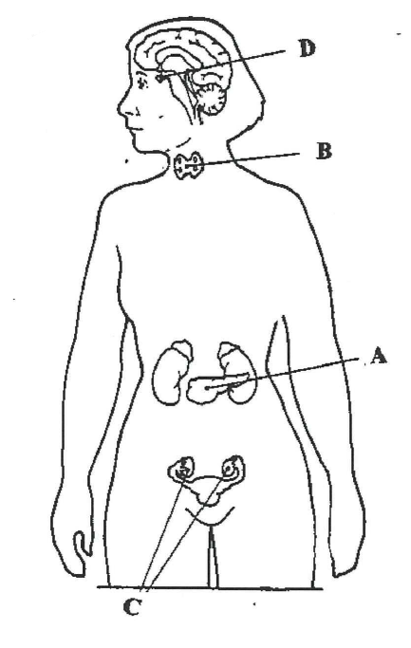
18. Which of the following is CORRECT?

- A is the pancreas, B is the thyroid, C is the ovary and D is the pituitary.
- A is the ovary, B is the pituitary, C is the thyroid and D is the parathyroid.
- A is the thyroid, B is the ovary, C is the pituitary and D is the pancreas.
- A is the pancreas, B is the pituitary, C is the ovary and D is the parathyroid.

19. Choose the correct statement that describes the type of receptor and the stimulus that it responds to:

 | Type of receptor | Stimulus
a) | Chemoreceptor | Light
b) | Thermoreceptor | Strong pressure
c) | Osmoreceptor | Light pressure
d) | Chemoreceptor | Change in pH

20. The chemical that transmits a nerve stimulus via a somatic pathway to a muscle fibre is

- Noradrenaline.
- Cholesterol.
- Acetylcholine.
- Adenosine triphosphate.

21. Which statement about bacteria and viruses is INCORRECT?

- Bacteria cells are generally larger than viruses.
- Bacteria and viruses both reproduce in the same way.
- Bacteria and viruses both lack a true nucleus.
- Bacteria cells have a cell wall and viruses do not.
22. A footballer, having received a blow to the head, has come off the field. She complains of having blurred vision. The most likely point of contact would have been the

- front of the head.
- left hand-side of the head.
- right hand-side of the head.
- rear of the head.

23. Which of the following is true about active immunity?

- The antibody formed will attack any pathogen.
- Both B and T lymphocytes can play a role.
- It is short-lived because no memory cells are involved.
- Prepared immunoglobulins activate this type of immunity.

24. An individual contracted Lyme disease after a tick took a blood meal from them.
Which of the following methods would describe how this disease was transmitted?

- By contact
- By body fluids
- By a vector
- By ingestion

25. The enzyme that is found in human tears that helps to kill bacteria is called

- cerumen.
- lysozyme.
- vaccine.
- leukocyte.

26. Which of the following organs in LIST 1 correctly matches the mode of defence against a possible pathogen in LIST 2?
 | LIST 1 | LIST 2
a) | Trachea | Acidic pH
b) | Stomach | Sweat and sebum
c) | Skin | Impervious barrier
d) | Urethra | Digestive enzymes

27. When B lymphocytes bind to an antigen they undergo cell division to produce a

- macrophage and a memory cell.
- memory cell and a killer T cell.
- plasma cell and a macrophage.
- plasma cell and a memory cell.

28. Which of the following is NOT an example of a pathogen?

- Mosquito.
- Bacteria.
- Parasite.
- Fungi.

29. When an individual experiences a rapid onset of a fever they may feel

- cold and, as a consequence, vasodilation in the skin and shivering occurs.
- hot and, as a consequence, vasoconstriction in the skin and sweating occurs.
- cold and, as a consequence, vasoconstriction in the skin and shivering occurs.
- hot and, as a consequence, vasodilation in the skin and shivering occurs.

30. Vaccination programs that reduce the chance of disease in individuals and increase the immunity of a population is best described as

- Immunisation.
- artificial passive immunity.
- natural active immunity.
- herd immunity.

Section Two: Short answer 50% (100 Marks)
This section has seven (7) questions. Answer all questions. Write your answers in the spaces provided.

Spare pages are included at the end of this booklet. They can be used for planning your responses and/or as additional space if required to continue an answer.
Planning: If you use the spare pages for planning, indicate this clearly at the top of the page.
Continuing an answer: If you need to use the space to continue an answer, indicate in the original answer space where the answer is continued, i.e. give the page number. Fill in the number of the question(s) that you are continuing to answer at the top of the page.

Suggested working time for this section is 90 minutes.
Question 31 (19 MARKS)

Scientists wanted to test the hypothesis that stressful situations could lead to weight gain in humans. It has been acknowledged that glucocorticoids (namely cortisol), are released during times of stress and the presence of these hormones may cause weight gain.

To investigate this theory, scientists exposed the same number of rats (10) to increasingly more stressful situations and then allowed them access to an unlimited supply of food pellets for 15 minutes. To induce stress, the rats were kept in isolation and completely restrained by a belt lined with wool, which was appropriately sized, depending on the age and size of the rat. Once the time of restraint had elapsed, the amount of adrenocorticotropic hormone (ACTH) present in their blood was measured and the average calculated. The average amount of ACTH was measured in picograms per mL of blood. The rats were then freed and allowed access to the food. The scientists recorded the number of pellets that were eaten at each level of average ACTH.
The results from the experiment can be seen below.

 |  | Number of pellets eaten within 15 minutes after release.
 |  | Trials
Time of restraint (Hours) | Average amount of  ACTH in blood  (pg/mL) | 1 | 2 | 3 | Average
0 | 30 | 14 | 14.25 | 13.75 | 14
2 | 60 | 10 | 10.25 | 9.75 | 10
4 | 90 | 8.25 | 9 | 8.25 | 8.5
6 | 120 | 17 | 19 | 18 | 18
8 | 150 | 21 | 24 | 22.5
(a) Identify the independent and dependent variables.
____________________________________________________________________ ____________________________________________________________________
(2 marks)
(b) List three controlled variables that would ensure the test was fair.
_______________________________________________________________________________________________________________________________________________________________________________________________________________
(3 marks)

(c) Complete the table on the previous page by calculating the average number of pellets
eaten for the last test. (1 mark)

(d) Plot the results on the graph paper supplied on the next page. (Spare graph grid on page 27)
(5 marks)

(e) Describe the relationship between ACTH and glucocorticoids (namely cortisol). In your answer include where each of the hormones are released from.

____________________________________________________________________________________________________________________________________________________________________________________________________________________________________________________________________________________
(3 marks)
(f) Cortisol has the ability to pass directly through the membrane of liver cells. State what type of hormone cortisol is and explain how it stimulates the cell to form particular proteins.

______________________________________________________________________________________________________________________________________________________________________________________________________________________________________________________________________________________________________________________________________________________________________________________________________________________________
(3 marks)
(g) Upon reviewing the procedure of this experiment, an independent scientist claimed,

“The procedure for this experiment was not conducted in an ethical way”.

Explain what the independent scientist meant by this statement.
____________________________________________________________________________________________________________________________________________________________________________________________________________________________________________________________________________________
(2 marks)
Question 32 (14 MARKS)
- Complete the diagram below of a reflex arc, by drawing a myelinated unipolar neuron in the appropriate space below. (1 mark)

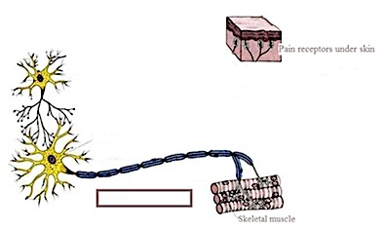
Pain receptors under skin
Skeletal muscle

- Indicate with an arrow in the rectangular box above, the direction of the nerve impulse through the axon above the rectangular box. (1 mark)

- Complete the following table.
Part | Function
Cell Body
Dendrites
Myelin sheath
Axon
(4 marks)

(d) Label each neuron in the diagram above according to their functional type.
(3 marks)

(g) List three characteristics of a spinal reflex
_______________________________________________________________________________________________________________________________________________________________________________________________________________
(3 marks)

Question 33 (12 MARKS)

Below is an action potential graph, showing the outcome from two different stimuli on the same neuron. Looking at the graph below, answer the questions that follow.
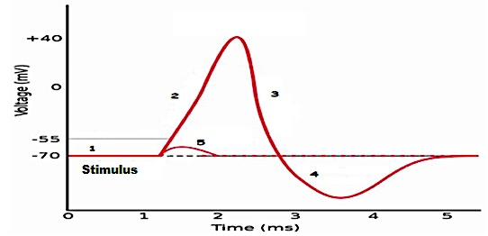

- The first stimulus resulted in the line labelled with the number 5. State TWO reasons why the potential difference quickly returned to -70mV.
_______________________________________________________________________________________________________________________________________________________________________________________________________________
(2 marks)

- The second stimulus resulted in the line labelled with the numbers 2, 3 and 4.
State TWO events that could not possibly occur during the phases shown by the sections labelled 2, 3 and 4.
_________________________________________________________________________________________________________________________________________________________________________________________________________________________________________________________________________________________________________________________________________________________
(2 marks)

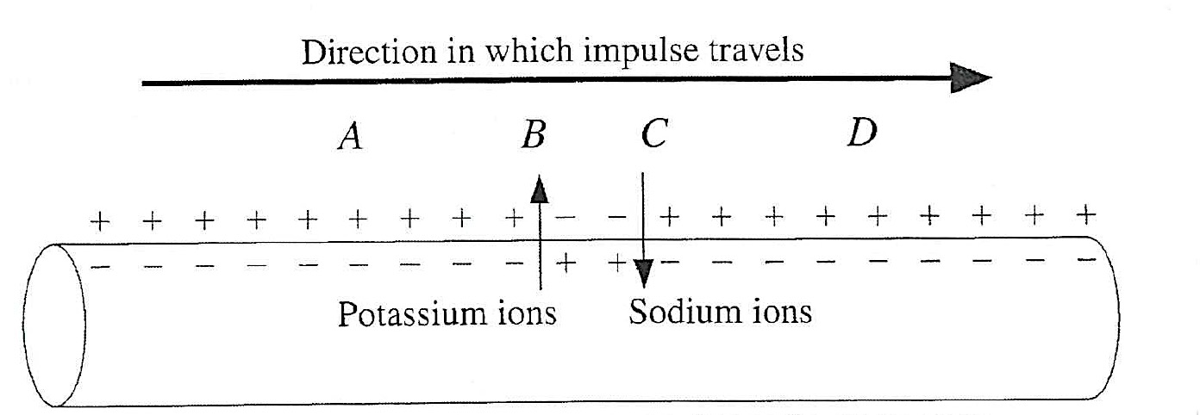
- The diagram below shows a nerve impulse travelling along an axon.

  - At which point (A, B, C or D on the axon) does the depolarisation of the nerve impulse (section 2 on the above graph) commence?

________________________________________________________________
(1 mark)
  - Explain your choice of answer in question (c) (i)

________________________________________________________________ ________________________________________________________________ ________________________________________________________________ ________________________________________________________________
(2 marks)
- Look at the diagram below of the different nerve fibres and answer the questions that follow.
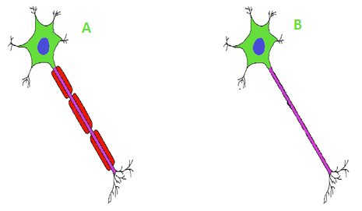
- State which nerve fibres shown above would be myelinated or unmylinated and
whether they would be found in grey or white matter.

A ________________________________________
B ________________________________________
(2 marks)
- State which of the nerve fibres above would conduct an impulse faster and
briefly explain why.

________________________________________________________________
________________________________________________________________
________________________________________________________________
________________________________________________________________
________________________________________________________________
________________________________________________________________
________________________________________________________________
(3 marks)
Question 34 (18 MARKS)
The graph below shows the body’s primary and secondary response to an antigen
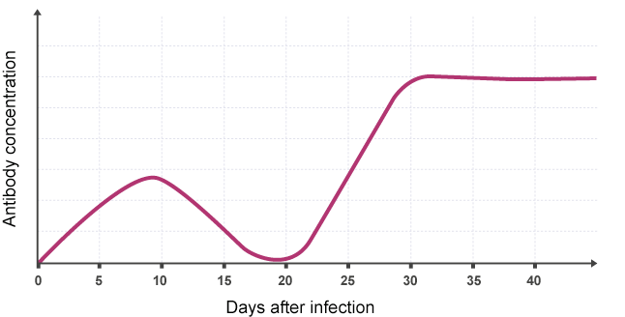
- Use the above graph to help fill in the table below which compares the Primary response to an infection to the Secondary response.

 | Primary response | Secondary response
Speed of response
Antibody numbers
(2 marks)

- Explain why the body is able to respond this way during the second exposure to the antigen

____________________________________________________________________
________________________________________________________________________________________________________________________________________________________________________________________________________________________________________________________________________________
(2 marks)

- Describe THREE ways in which antibodies can render an antigen inactive
____________________________________________________________________________________________________________________________________________________________________________________________________________________________________________________________________________________________________________________________________________________________________________________________________________________________________________________________________________________________
(3 marks)

- After the first exposure to the bacterium, the person experienced an elevation of their body temperature.
(i) State the name of this non-specific response. _______________ (1 mark)

(ii) State the name of two effectors in the above response and describe how they contribute to this non-specific defence. _____________________________________________________________________________________________________________________________________________________________________________________________________________________________________________________________________________________________________________________________________
(2 marks)

(iii) Describe two benefits an elevated body temperature is believed to provide as the
body fights against a disease.

_________________________________________________________________ _________________________________________________________________ _________________________________________________________________ _________________________________________________________________
(2 marks)

- There are two types of antibiotics. Name each type and describe how they kill bacteria.

____________________________________________________________________________________________________________________________________________________________________________________________________________________________________________________________________________________________________________________________________________________________________________________________________________________________________________________________________________________________
(4 marks)

- The number of doctors that are becoming reluctant to prescribe antibiotics for every patient that presents with an infection is increasing. Describe why doctors would feel this way.
________________________________________________________________________________________________________________________________________________________________________________________________________________________________________________________________________________________________________________________________________________________________________________________________________________________
(2 marks)

Question 35 (12 MARKS)
Below is an enlargement of the outer layers of the head. Use the diagram to answer the following questions.
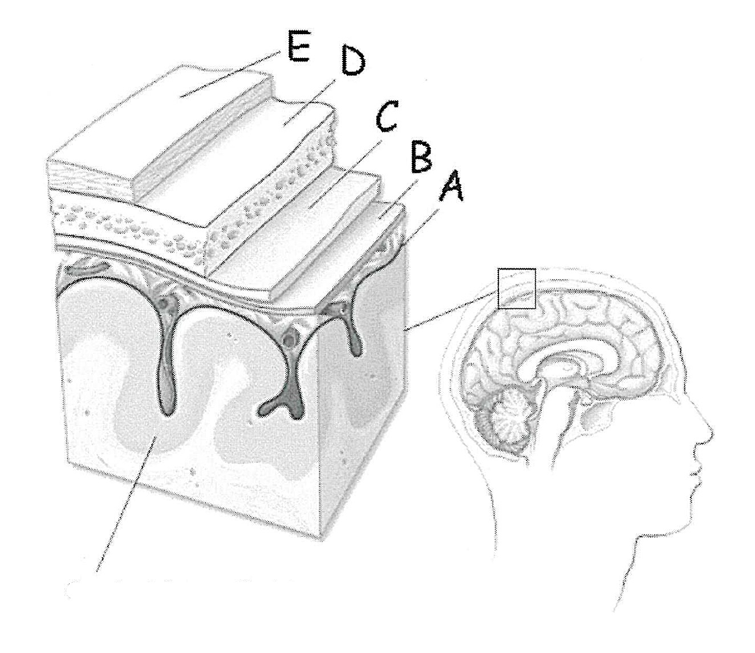
Cerebral cortex (brain)
  - Name the following structures:

    - Structure D __________________________________
    - Structure A __________________________________
(2 marks)

  - Using two letters only (from the diagram above), identify the two structures between which cerebrospinal fluid is located.
_______________ and ________________
(2 marks)
  - Describe TWO functions of the cerebrospinal fluid
_________________________________________________________________________________________________________________________________________________________________________________________________________________________________________________________________________________________________________________________________________________________
(2 marks)
  - Complete the table below by stating the specific part of the brain responsible for regulating the homeostatic processes described.
 | Process | Part of the brain responsible for regulation
(i) | Vasodilation of blood vessels
(ii) | Decrease in metabolic rate
(iii) | Memory and logic
(iv) | Balance and coordination
(4 marks)
  - The spinal cord is also part of the central nervous system and is protected by similar structures to those found surrounding the brain. Describe the difference between the brain and spinal cord in terms of the distribution of grey and white matter.
__________________________________________________________________________________________________________________________________________
(2 marks)
Question 36 (12 MARKS)
A marathon runner is just about to finish a race in hot weather and he is sweating, feels thirsty and his skin is red and hot.

- Complete the following table to summarise the body’s symptoms to the exercise in the hot environment.
Symptoms | Stimulus | Receptor | Modulator | Effector | Response
Red and  hot skin | Increased  body  temperature | Thermoreceptor | Hypothalamus
Sweating | Increased  body  temperature | Thermoreceptor |  | Sweat glands | Sweat released  onto the surface of this skin
Thirsty | Increased  osmotic  pressure |  | Hypothalamus |  | Conscious decision to have a drink
(5 marks)
- After the race, despite the large volumes of plain water consumed by the athlete, he feels light headed, has a headache and feels nauseous. As a result of the light headedness, the athlete stumbled forwards and grazed his hands. The palms of his hands are now bleeding, red, swollen, hot and painful.
  - Based on the symptoms listed, name the internal non-specific defensive response that has been stimulated as a result of the injury.
________________________________________________________________
(1 mark)
  - Describe the sequence of events that would keep the wound free of infection and allow the wound to heal.

__________________________________________________________________________________________________________________________________________________________________________________________________________________________________________________________________________________________________________________________________________________________________________________________________________________________________________________________________________________________________________________________________________________________________________________________________________________________________________________________________________
(6 marks)
QUESTION 37 (15 MARKS)
Michelle has recently taken up running as a hobby. She notices that each time she runs for an extended period, there are significant changes to her breathing depth and rate.
- Michelle’s change in breathing is in response to high levels of which dissolved gas in her blood plasma?
_____________________________________________________________________
(1 mark)
- Name the metabolic reaction through which this gas is produced
_____________________________________________________________________
(1 mark)
- Using the stimulus – response model, draw a diagram in the space below to demonstrate the changes occurring in Michelle’s body with respect to gas concentration regulation. (5 marks)

- While running, Michelle was listening to her iPod and not paying attention to the traffic. She didn’t hear the car behind her as she stepped off the footpath. The driver of the car sounded the horn and screeched to a halt, just missing her.

  - Name the response that would be initiated during this experience
________________________________________________________________
(1 mark)
  - Which specific division of the nervous system is responsible for initiating this response?
________________________________________________________________
(1 mark)

- Describe THREE beneficial ways that Michelle’s body may have responded to this frightening situation and how these responses would have been advantageous to her.
___________________________________________________________________________________________________________________________________________________________________________________________________________________________________________________________________________________________________________________________________________________________________________________________________________________________________________________________________________________________________
(6 marks)

Section Three: Extended answer 20% (40 Marks)
This section contains three (3) questions. You must answer two (2) questions. Make sure you clearly indicate which question you are answering and write your answers in the space provided.
Spare pages are included at the end of this booklet. They can be used for planning your responses and/or as additional space if required to continue an answer.
- Planning: If you use the spare pages for planning, indicate this clearly at the top of the page.
  - Continuing an answer: If you need to use more space to continue an answer, indicate in the original answer space where the answer is continued, i.e. give the page number. Write the number of the question(s) that you are continuing to answer at the top of the additional space page.
Responses could include clearly labelled diagrams with explanatory notes; lists of points with linking sentences; clearly labelled tables and graphs; and annotated flow diagrams with introductory notes.
Suggested working time: 40 minutes.
Question 38 (20 marks)
(a) The pituitary gland is sometimes referred to as the “master gland”, however, it could be argued the hypothalamus should have this title.
  - Describe how the hypothalamus controls the secretion of hormones from the anterior and posterior lobes of the pituitary gland.
(6 marks)
  - Name one hormone that is released from the anterior lobe of the pituitary gland and one hormone that is released from the posterior lobe of the pituitary gland and describe in detail their target structures and their main effects.
(6 marks)
(b) Both the nervous and endocrine systems allow the body to maintain homeostasis. Compare and contrast the way in which the two systems operate.
(8 marks)

Question 39 (20 marks)
Bacillus cereus is a bacterium that can cause food poisoning, usually contracted from rice meals which have been allowed to rest at room temperature for hours, particularly at a buffet. If the bacterium is exposed to high temperatures or acidic conditions, they will enter a dormant state and develop a heat and chemical resistant cell wall, until their surrounding environment is favourable again. This dormant and protective state is referred to as being an endospore.
An infection is initially indicated by vomiting and/or diarrhoea and then 30 minutes to 6 hours later the lymph glands/nodes can become swollen. Most patients recover within 6 to 24 hours.

- Describe how the non-specific defences initially triggered in response to the infection destroy or remove some of the Bacillus cereus and explain why they are incapable of completely eradicating the bacteria.
(10 marks)
(b) The swollen lymph nodes are an indication of the specific defences the body employed to destroy the bacterium. State what an antibody is and describe the steps that would occur during a humoral (antibody-mediated) response.
(10 marks)
Question 40 (20 marks)
Under normal circumstances, homeostatic control mechanisms ensure blood glucose levels (BGLs) are maintained at a constant level. People with diabetes mellitus are incapable of maintaining their BGLs and they can experience increased urination (polyuria) if they consume a meal high in glucose.

- Explain how the pancreas and liver would reduce the BGLs in someone who was not a diabetic. (5 marks)

- Explain the cause and treatments of type 1 and type 2 diabetes. (6 marks)

- The high amounts of glucose in a diabetic’s blood plasma can lead to a high osmotic pressure within the blood plasma.
Describe what effect this stimulus would have on the action of antidiuretic hormone (ADH) in controlling water balance and explain why a diabetic would urinate excessively and feel thirsty. (9 marks)

END OF EXAM

Spare grid for question 31 (d)

